Metric System
# Source: AI Source: Provided by: [Data Path: Persons Table -> ID Column: 1, Name_En Column: Motasem Essam] -> From: [ChatGPT] on [7/17/2026]
The Metric System is a decimal-based system of measurement that uses powers of ten to measure physical quantities such as length, mass, volume, area, and temperature. It was developed in France during the late 18th century to provide a simple, universal, and standardized method of measurement.
The Metric System is the foundation of the International System of Units (SI) and is used in nearly every country in the world.

Definition
# Source: AI Source: Provided by: [Data Path: Persons Table -> ID Column: 1, Name_En Column: Motasem Essam] -> From: [ChatGPT] on [7/17/2026]
The Metric System is a standardized measurement system based on powers of ten, in which units can be converted by multiplying or dividing by 10, 100, 1000, and so on.
It provides a consistent and easily scalable framework for measuring physical quantities.

History
# Source: AI Source: Provided by: [Data Path: Persons Table -> ID Column: 1, Name_En Column: Motasem Essam] -> From: [ChatGPT] on [7/17/2026]
The Metric System was introduced during the French Revolution.
Key milestones:
- 1791 – Proposal for a universal measurement system.
- 1795 – Official adoption in France.
- 19th century – Gradual international adoption.
- 1960 – Became the foundation for the International System of Units (SI).

Characteristics
# Source: AI Source: Provided by: [Data Path: Persons Table -> ID Column: 1, Name_En Column: Motasem Essam] -> From: [ChatGPT] on [7/17/2026]
The Metric System is:
- Decimal-based.
- Easy to convert between units.
- Internationally recognized.
- Based on standardized units.
- Designed for scientific and everyday use.
- The foundation of the SI system.

Fundamental Principle
# Source: AI Source: Provided by: [Data Path: Persons Table -> ID Column: 1, Name_En Column: Motasem Essam] -> From: [ChatGPT] on [7/17/2026]
The Metric System uses powers of ten.
Examples:
$$1\text{ km}=1000\text{ m} \\ 1\text{ m}=100\text{ cm} \\ 1\text{ kg}=1000\text{ g}$$
This decimal structure makes conversions straightforward.

Common Metric Quantities
# Source: AI Source: Provided by: [Data Path: Persons Table -> ID Column: 1, Name_En Column: Motasem Essam] -> From: [ChatGPT] on [7/17/2026]
The Metric System is commonly used to measure:
- Length
- Mass
- Volume
- Capacity
- Area
- Temperature
- Time (although SI retains traditional time units)
- Speed
- Density

Metric Units of Length
# Source: AI Source: Provided by: [Data Path: Persons Table -> ID Column: 1, Name_En Column: Motasem Essam] -> From: [ChatGPT] on [7/17/2026]
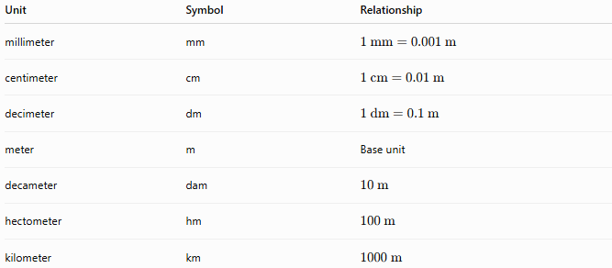
Unit | Symbol | Relationship
millimeter | mm | $$1\text{ mm}=0.001\text{ m}$$
centimeter | cm | $$1\text{ cm}=0.01\text{ m}$$
decimeter | dm | $$1\text{ dm}=0.1\text{ m}$$
meter | m | Base unit
decameter | dam | $$10\text{ m}$$
hectometer | hm | $$100\text{ m}$$
kilometer | km | $$1000\text{ m}$$

Metric Units of Mass
# Source: AI Source: Provided by: [Data Path: Persons Table -> ID Column: 1, Name_En Column: Motasem Essam] -> From: [ChatGPT] on [7/17/2026]
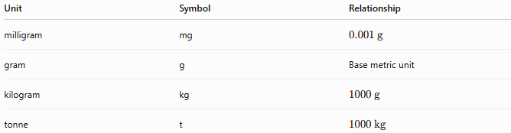
Unit | Symbol | Relationship
milligram | mg | $$0.001\text{ g}$$
gram | g | Base metric unit
kilogram | kg | $$1000\text{ g}$$
tonne | t | $$1000\text{ kg}$$

Metric Units of Volume
# Source: AI Source: Provided by: [Data Path: Persons Table -> ID Column: 1, Name_En Column: Motasem Essam] -> From: [ChatGPT] on [7/17/2026]
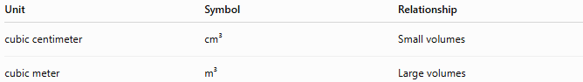
Unit | Symbol | Relationship
cubic centimeter | cm³ | Small volumes
cubic meter | m³ | Large volumes

Metric Units of Capacity
# Source: AI Source: Provided by: [Data Path: Persons Table -> ID Column: 1, Name_En Column: Motasem Essam] -> From: [ChatGPT] on [7/17/2026]

Unit | Symbol | Relationship
milliliter | mL | $$0.001\text{ L}$$
liter | L | Base metric capacity unit
kiloliter | kL | $$1000\text{ L}$$

Metric Units of Area
# Source: AI Source: Provided by: [Data Path: Persons Table -> ID Column: 1, Name_En Column: Motasem Essam] -> From: [ChatGPT] on [7/17/2026]
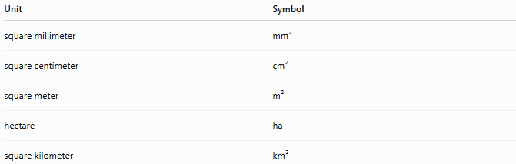
Unit | Symbol
square millimeter | mm²
square centimeter | cm²
square meter | m²
hectare | ha
square kilometer | km²

Metric Units of Temperature
# Source: AI Source: Provided by: [Data Path: Persons Table -> ID Column: 1, Name_En Column: Motasem Essam] -> From: [ChatGPT] on [7/17/2026]
The Metric System commonly uses:
- degree Celsius (°C)
The SI system additionally defines the kelvin (K) as the base unit of thermodynamic temperature.

Metric Prefixes
# Source: AI Source: Provided by: [Data Path: Persons Table -> ID Column: 1, Name_En Column: Motasem Essam] -> From: [ChatGPT] on [7/17/2026]
Metric prefixes represent multiples and fractions of units.
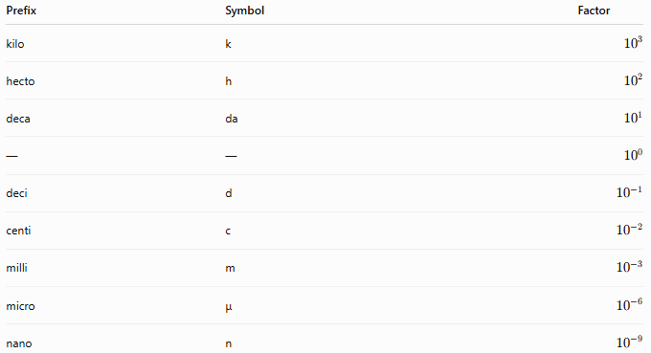
Prefix | Symbol | Factor
kilo | k | $${10}^{3}$$
hecto | h | $${10}^{2}$$
deca | da | $${10}^{1}$$
— | — | $${10}^{0}$$
deci | d | $${10}^{-1}$$
centi | c | $${10}^{-2}$$
milli | m | $${10}^{-3}$$
micro | μ | $${10}^{-6}$$
nano | n | $${10}^{-9}$$

Examples
# Source: AI Source: Provided by: [Data Path: Persons Table -> ID Column: 1, Name_En Column: Motasem Essam] -> From: [ChatGPT] on [7/17/2026]
Example 1
Convert
$$5\text{ km}$$
to meters.
$$5×1000=5000\text{ m}$$

Example 2
Convert
$$250\text{ cm}$$
to meters.
$$250÷100=2.5\text{ m}$$

Example 3
Convert
$$3.5\text{ kg}$$
to grams.
$$3.5×1000=3500\text{ g}$$

Example 4
Convert
$$750\text{ mL}$$
to liters.
$$750÷1000=0.75\text{ L}$$

Advantages
# Source: AI Source: Provided by: [Data Path: Persons Table -> ID Column: 1, Name_En Column: Motasem Essam] -> From: [ChatGPT] on [7/17/2026]
The Metric System:
- Uses simple decimal conversions.
- Is easy to learn.
- Is internationally accepted.
- Reduces calculation errors.
- Supports scientific accuracy.
- Facilitates international trade.

Disadvantages
# Source: AI Source: Provided by: [Data Path: Persons Table -> ID Column: 1, Name_En Column: Motasem Essam] -> From: [ChatGPT] on [7/17/2026]
The Metric System:
- May require conversion when working with countries using non-metric systems.
- Some traditional industries continue to use older measurement systems.

Applications
# Source: AI Source: Provided by: [Data Path: Persons Table -> ID Column: 1, Name_En Column: Motasem Essam] -> From: [ChatGPT] on [7/17/2026]
The Metric System is used in:
- Mathematics
- Science
- Physics
- Chemistry
- Biology
- Engineering
- Medicine
- Manufacturing
- Construction
- Agriculture
- Commerce
- Education

Everyday Examples
# Source: AI Source: Provided by: [Data Path: Persons Table -> ID Column: 1, Name_En Column: Motasem Essam] -> From: [ChatGPT] on [7/17/2026]
The Metric System is used when:
- Measuring height in centimeters.
- Measuring road distances in kilometers.
- Buying food in kilograms.
- Measuring liquids in liters.
- Recording body temperature in degrees Celsius.
- Measuring medicine in milliliters.

Common Mistakes
# Source: AI Source: Provided by: [Data Path: Persons Table -> ID Column: 1, Name_En Column: Motasem Essam] -> From: [ChatGPT] on [7/17/2026]
- Confusing metric prefixes.
- Mixing metric and imperial units.
- Forgetting to square or cube conversion factors for area and volume.
- Using incorrect unit symbols (e.g., Km instead of km).

Key Points
# Source: AI Source: Provided by: [Data Path: Persons Table -> ID Column: 1, Name_En Column: Motasem Essam] -> From: [ChatGPT] on [7/17/2026]
- The Metric System is a decimal-based measurement system.
- It uses powers of ten for conversions.
- It forms the basis of the International System of Units (SI).
- It is used in nearly every country.
- It simplifies calculations and scientific measurements.

Metric System vs. SI System
# Source: AI Source: Provided by: [Data Path: Persons Table -> ID Column: 1, Name_En Column: Motasem Essam] -> From: [ChatGPT] on [7/17/2026]
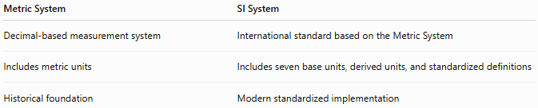
Metric System | SI System
Decimal-based measurement system | International standard based on the Metric System
Includes metric units | Includes seven base units, derived units, and standardized definitions
Historical foundation | Modern standardized implementation

Metric System vs. Imperial System
# Source: AI Source: Provided by: [Data Path: Persons Table -> ID Column: 1, Name_En Column: Motasem Essam] -> From: [ChatGPT] on [7/17/2026]
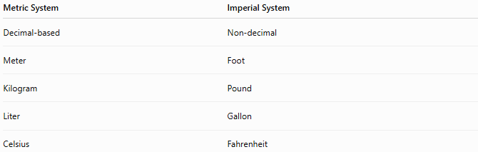
Metric System | Imperial System
Decimal-based | Non-decimal
Meter | Foot
Kilogram | Pound
Liter | Gallon
Celsius | Fahrenheit

Metric System vs. United States Customary System
# Source: AI Source: Provided by: [Data Path: Persons Table -> ID Column: 1, Name_En Column: Motasem Essam] -> From: [ChatGPT] on [7/17/2026]
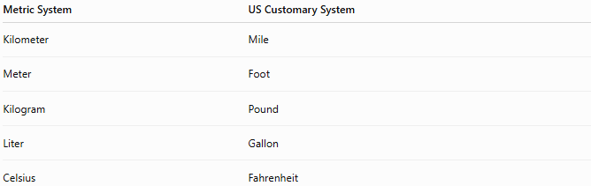
Metric System | US Customary System
Kilometer | Mile
Meter | Foot
Kilogram | Pound
Liter | Gallon
Celsius | Fahrenheit

Conclusion
# Source: AI Source: Provided by: [Data Path: Persons Table -> ID Column: 1, Name_En Column: Motasem Essam] -> From: [ChatGPT] on [7/17/2026]
The Metric System is a decimal-based measurement system that uses standardized units and powers of ten to measure physical quantities. Developed in France in the late eighteenth century, it became the foundation of the modern International System of Units (SI). Its simple conversion rules, international acceptance, and consistency have made it the preferred measurement system for science, engineering, medicine, education, commerce, and everyday life throughout most of the world.

